System Documentation
Form
Form name | Use
Form Main | It is used to show data of program and help to orientate in the system
Form Input | It is used to input new data to the program

Form Main Objects
Name, Last name | Label | Shows information that buyer should to fill in, about who is a buyer
City | Label | Shows where user going to reserve hotel
Check-in, check-out | Label | Shows when buy going to live in the hotel
Adults, children | Label | Shows how many people are travelling and sorts the according to the age and how many tickets he is going to to buy

Form Main Input Objects
Name, Last name, City, Check-in, Check-out, Adults, Children | Entry | Used to write al information according to the labels about reservation.
Reserve | Button | Used to submit all entered information and buyer is ready to reserve hotel

Possible Adaptive Maintenance
To improve the system, future work and include several aspects. They are:
● To make more forms to get more information about buyer
● To make special form for travelers with limits. For example: human is blind or deaf
● To make system that would able to work online or on different platforms like smartphones or mac.

User manual
This program is very easy to use. To begin you need to open program by mouse and click on the program icon twice. Secondly, you need to write all the information that system requires. It includes writing about your name, last name, date of check-in, date of check-out, city, where you are going to live and how many tickets you are buying.
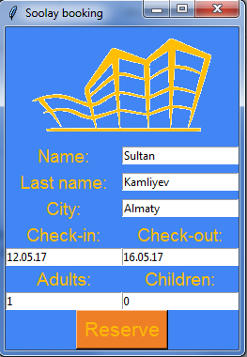
After you press button pay, all the information, that you entered, saves in the text file. Text file is a database, for a system to know who, where, when had reserved hotel. 